

**GAP ANALYSIS DOCUMENT (GAD) SIGN-OFF**

**Authorization Memorandum**

This form is to sign-off completion of the Requirement Phase for **CAMPUS MANAGEMENT SOFTWARE AT WORLD SKILL CENTER (WSC).**

World Skill Centre (WSC) acknowledges receipt of the deliverables as part of the Requirement Phase through the submission of this document.

|  |  |
| --- | --- |
| **MODULE NAME** | **HRMS Module** |

| **VERSION HISTORY** | | | |
| --- | --- | --- | --- |
| **Version** | **Author** | **Date** | **Changes** |
|  |  |  |  |
|  |  |  |  |

**WSC AUTHORITY NAME AND**  **SIGNATURE**

**SOUL AUTHORITY NAME AND**  **SIGNATURE**

Pages 1 of 24



**GAP Analysis Document**

Of

**HRMS module**

For Implementation of

**Campus Management Software**

at

**World Skill Center (WSC)**



**Sustainable Outreach And Universal**

**Leadership (SOUL) Limited**

Contents

A. Introduction 3

B. Overview of the Document 3

C. List of Screen 4

D. Recruitment Workflow 6

E. Employee Life-Cycle Workflow 8

F. Leave Management Workflow 10

G. Shift Management Workflow 12

H. Attendance Workflow 14

I. Screen-Wise Gap 16

1. Masters 16

2. Recruitment 17

3. Employee Life-Cycle 19

4. Leaves 21

5. Attendance 23

# **Introduction**

The World Skill Center (WSC) is a premier advanced skill training institute established by the Government of Odisha, Skill Development and Technical Education Department, through the Odisha Skill Development Authority (OSDA). The WSC will impart advanced skill training in eight trades from engineering and service sectors. WSC caters primarily to induct the best talent from ITIs and Polytechnics and train them to become globally employable in emerging areas such as "Industry 4.0". WSC is housed in a state-of-the-art, 18-storey, air-conditioned building with nearly half a million square feet of space in the heart of capital city of Bhubaneswar.

With the Implementation of campus management software for WSC the goal is to streamline the operations and functions of the campus by integrating various processes, such as admissions, course registration, academic progress tracking, and financial management, HRMS, Procurement and Inventory management, etc into a unified system. The implementation also aims at providing a user-friendly interface for all stakeholders, making it easier for them to access the necessary information and complete their tasks with ease. The modules to be covered during the implementation of the software includes:

|  |  |
| --- | --- |
| Students Management Modules | Infrastructure Management |
| Academic System | Finance and Accounting System |
| Procurement & Inventory Management | Training and Placement |
| Human Resources Management System | Application Integration |

# **Overview of the Document**

The Gap analysis document is a detailed report that provides an overview of the

gaps between the current state of the project and the desired state, and develop recommendations to close those gaps. Conducting a gap analysis can help us to improve our product and profitability by allowing us to pinpoint “gaps” present in our software. Once it’s complete, we will be able to better focus on our resources and energy on those identified areas in order to improve them.

This document covers all the gaps between the existing software and functional requirements provided by WSC SME’s for HRMS module

# **List of Screen**

|  |  |  |  |
| --- | --- | --- | --- |
| **SL no** | **Name of the Screens** | **Changes in Existing** | **Is New Screen ?** |
|  | Department | No | No |
|  | Branch | No | No |
|  | Designation | No | No |
|  | Employment Type | No | No |
|  | Employee Grade | No | No |
|  | Employee Health Insurance | No | No |
|  | Employee | Yes | No |
|  | Employee Group | No | No |
|  | Center Selection Master | No | Yes |
|  | Job Requisition | Yes | No |
|  | Staffing Plan | Yes | No |
|  | Job Opening | Yes | No |
|  | Job Applicant | Yes | No |
|  | Recruitment Exam Declaration | No | Yes |
|  | Recruitment Exam Center Allocation | No | Yes |
|  | Recruitment Exam Admit Card Generation Tool | No | Yes |
|  | Recruitment Exam Admit Card Generation | No | Yes |
|  | Recruitment Exam Result Declaration Tool | No | Yes |
|  | Recruitment Exam Result Declaration | No | Yes |
|  | Interview Type | No | No |
|  | Interview Round | No | No |
|  | Interview | No | No |
|  | Job Offer | Yes | No |
|  | Appointment Letter Template | No | No |
|  | Appointment Letter | No | No |
|  | Employee Onboarding Template | No | No |
|  | Employee Onboarding | Yes | No |
|  | Employee Skill Map | No | No |
|  | Employee Promotion | No | Yes |
|  | Employee Transfer | No | Yes |
|  | Employee Grievance | Yes | No |
|  | Grievance Type | No | Yes |
|  | Employee Separation Template | No | Yes |
|  | Employee Separation | Yes | No |
|  | Staff Suggestion | No | Yes |
|  | Employee Resignation | No | Yes |
|  | Employee Profile Updation | No | Yes |
|  | Employee Re-engagement | No | Yes |
|  | Holiday List | No | No |
|  | Leave Type | Yes | No |
|  | Leave Period | No | No |
|  | Leave Policy | Yes | No |
|  | Leave Block List | Yes | No |
|  | Leave Encashment | No | No |
|  | Leave Allocation | No | No |
|  | Leave Policy Assignment | No | No |
|  | Compensatory Leave Request | No | No |
|  | Shift Type | No | No |
|  | Shift Request | No | No |
|  | Shift Assignment | No | No |
|  | Attendance | No | No |
|  | Employee Attendance Tool | No | No |
|  | Attendance Request | No | No |
|  | Employee Check In | No | No |
|  | Upload Attendance | No | No |
|  | Appraisal Template | No | No |
|  | Appraisal | No | No |
|  | HR Settings | No | No |

# **Recruitment Workflow**

**Existing Recruitment Process Flow**

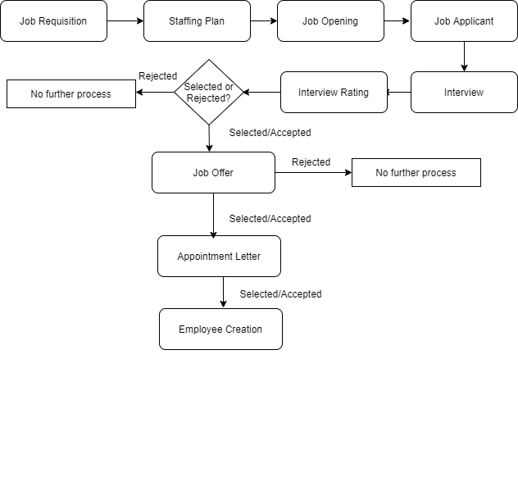

**WSC Recruitment Process Flow**

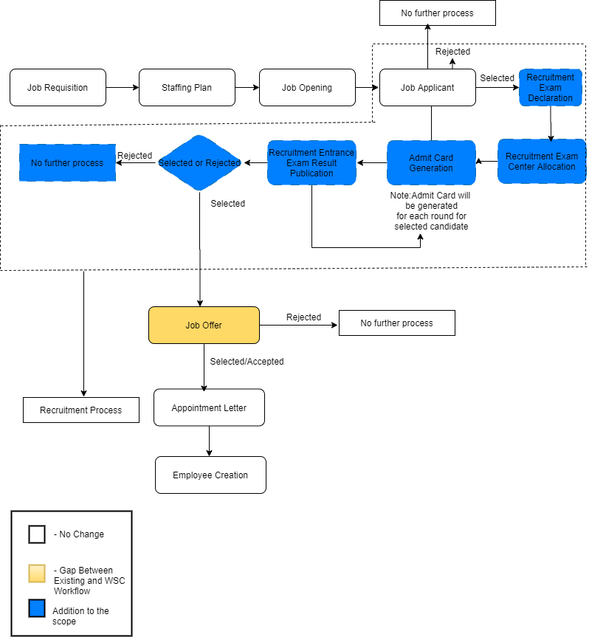

# **Employee Life-Cycle Workflow**

**Existing Employee Lifecycle Process Flow**

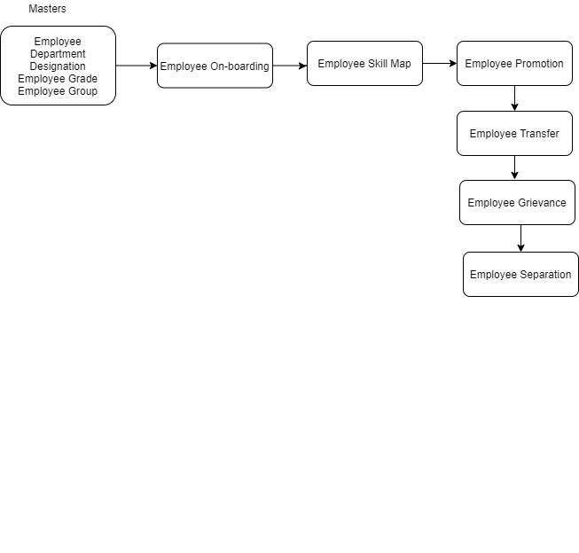

**WSC Employee Lifecycle Process Flow**

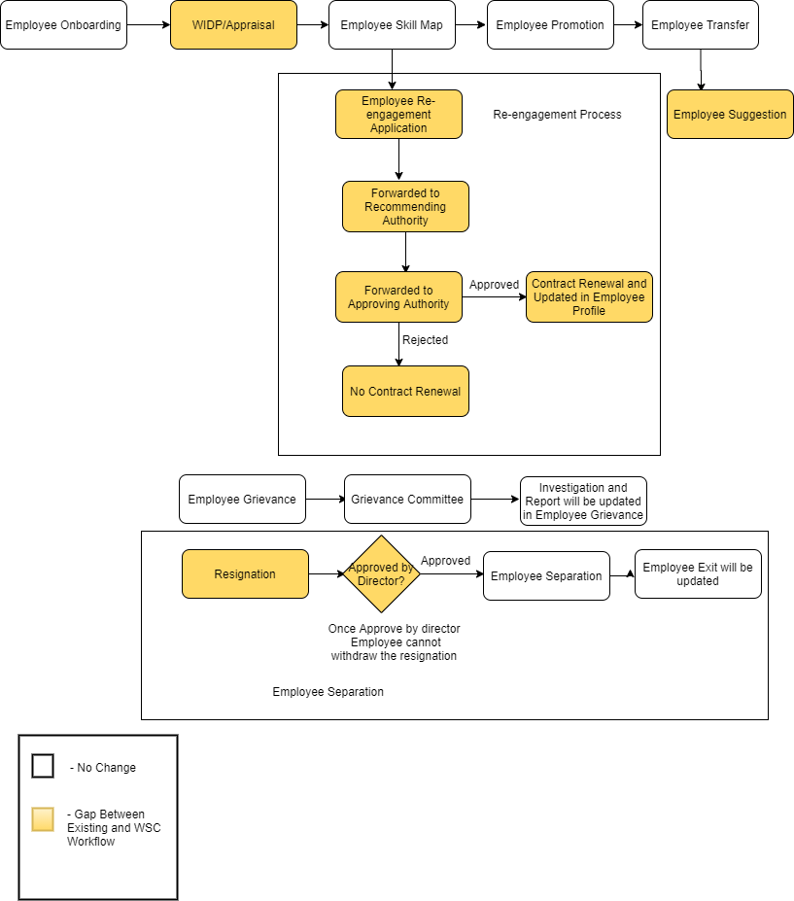

# **Leave Management Workflow**

**Existing Leave Management Process Flow**

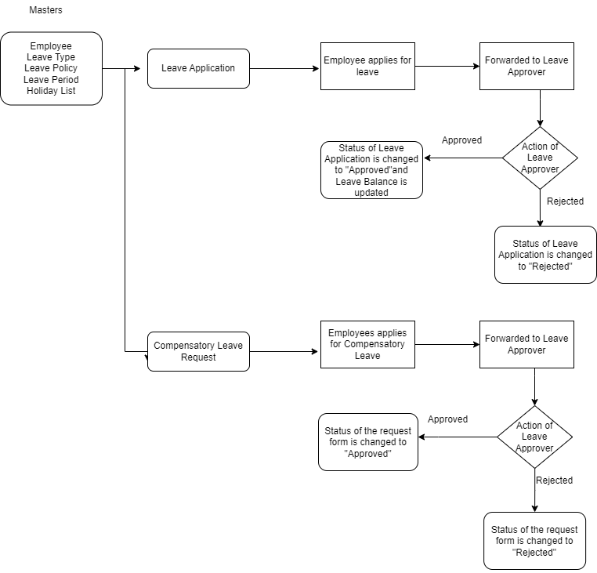

**WSC Leave Management Process Flow**

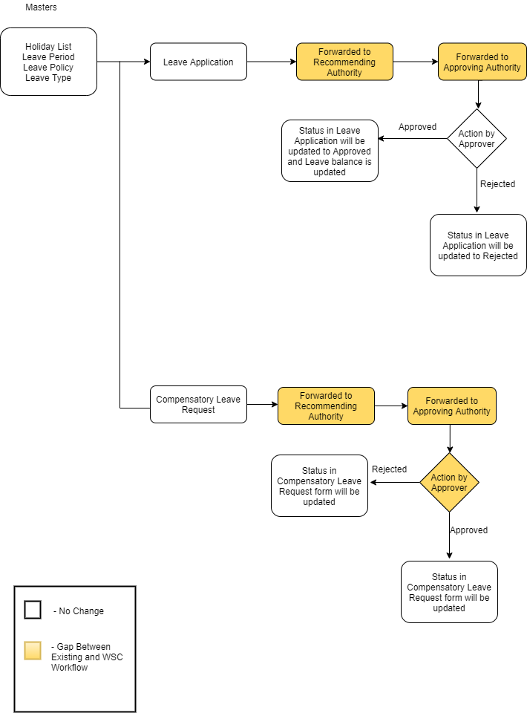

# **Shift Management Workflow**

**Existing Shift Management Process Flow**

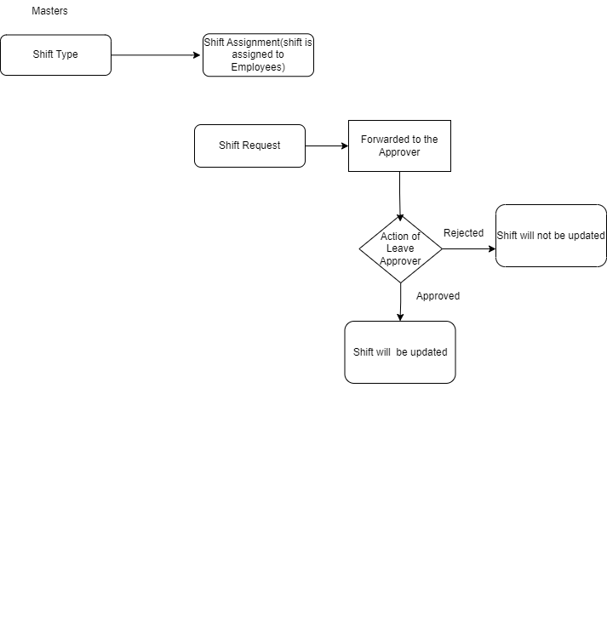

**WSC Shift Management Process Flow**

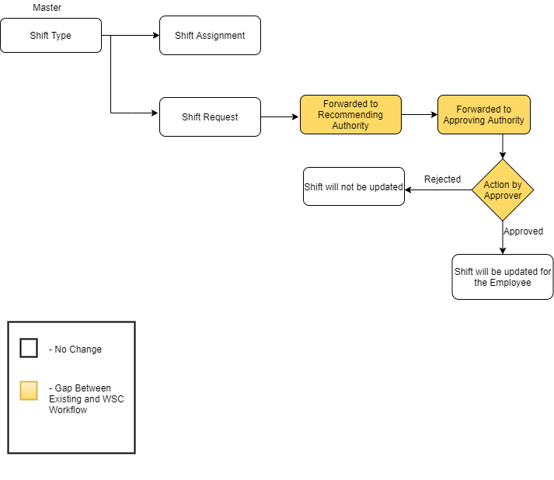

# **Attendance Workflow**

**Existing Attendance Flow**

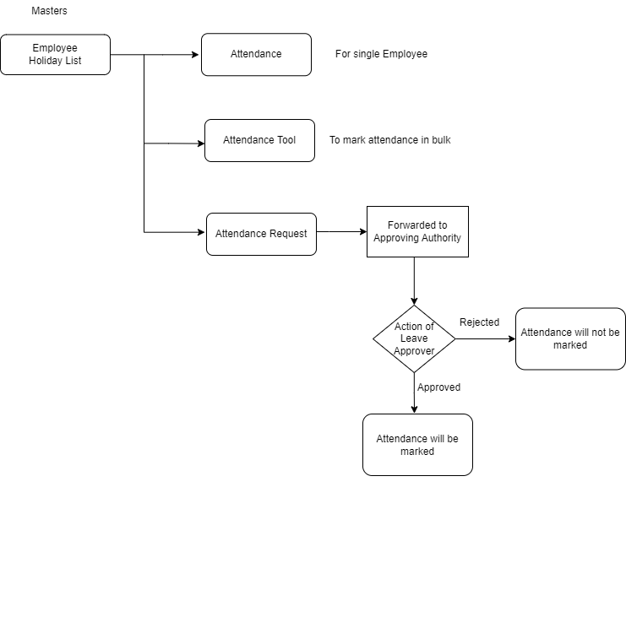

**WSC Attendance Process Flow**

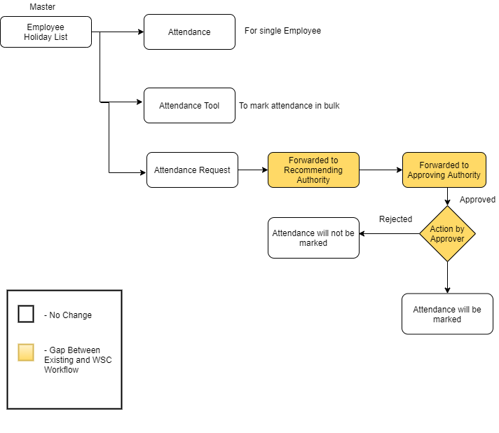

# **Screen-Wise Gap**

## **Masters**

### **Employee**

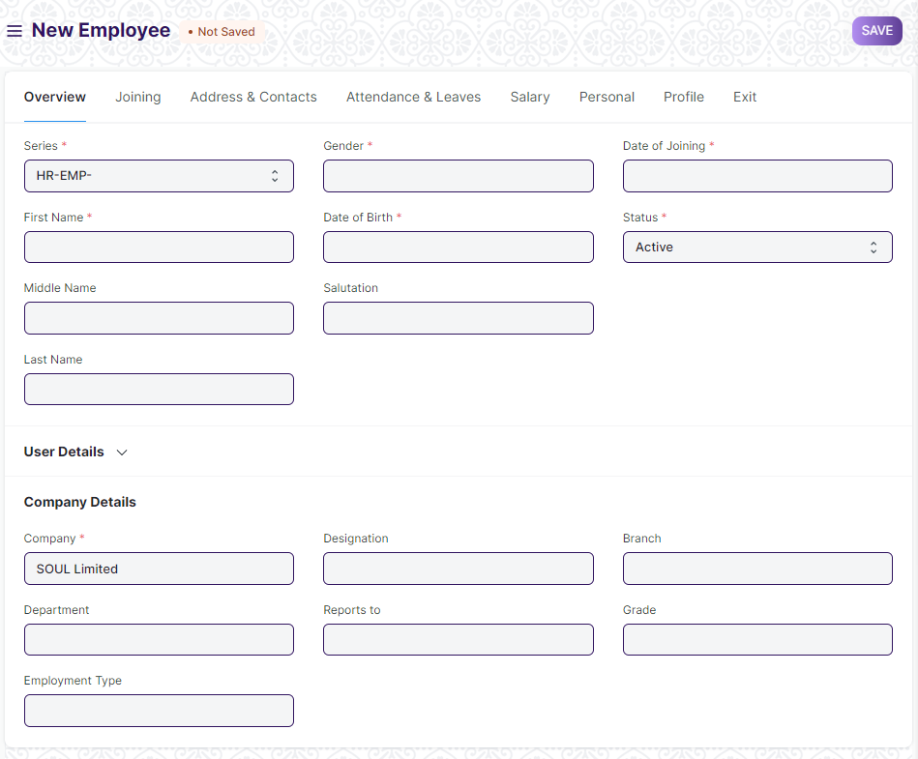

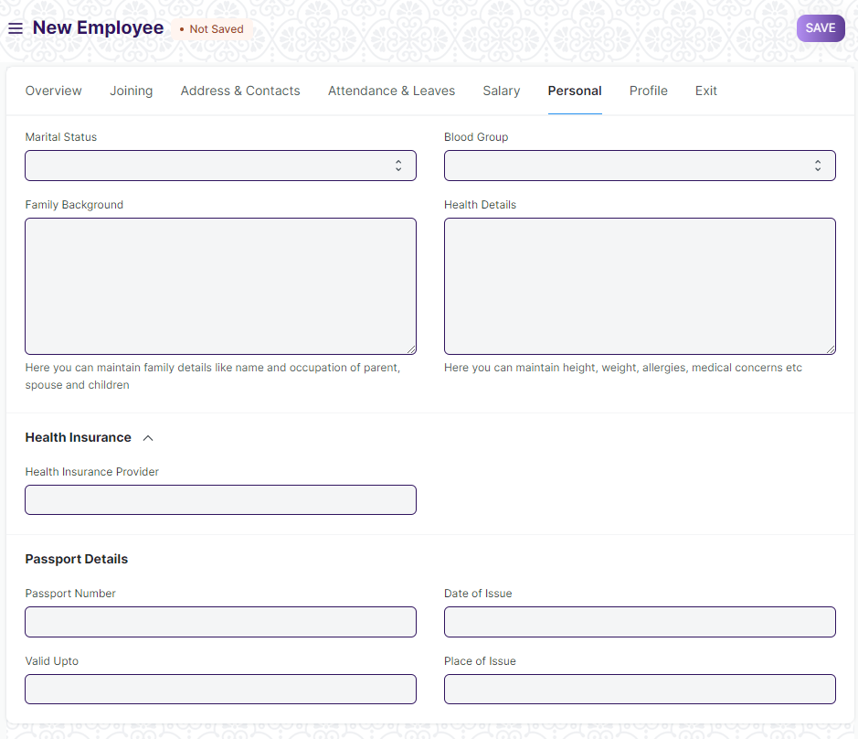

#### **Business Requirements:**

* Multiple Department/Designation allotted to an employee should be present in the Employee Screen under “**Company Details**”.
* caste and categories fields like PWD , ex service man etc need to be added.
* Family background details, health insurance details , educational qualification details should be maintained in tabular format in the employee screen.
* In **“Family Background Details”** following fields need to be added:

1. Father’s name
2. Mother’s name
3. Spouse name
4. Occupation details of Father,Mother and Spouse
5. Annual Income( Father,Mother and Spouse)
6. Address and Contact details.
7. Health Details like Height,Weight,medical concern for every family members(Father,Mother and Spouse).

* Visa Details needs to be added in the employee screen.
* **“Notice Period ”** details like No. Of Days,Status(Served/Not Served) should be present.

## **Recruitment**

### **Job Requisition**

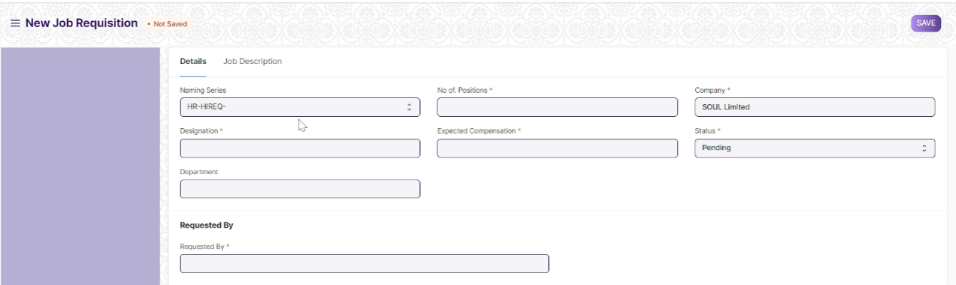

#### **Business Requirements:**

* Document Upload feature should be there in Job Requisition.
* Attachment names like TOR,Finance Approval.

### **Job Opening**

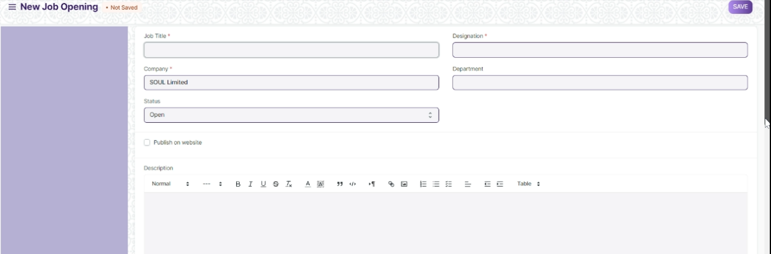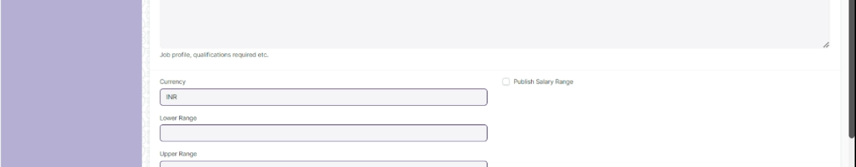

#### **Business Requirements:**

* Employment Type Should be there in the Job Opening Screen.
* Number of Selection round and Selection round details should be mentioned in the job opening screen.

### **Job Applicant**

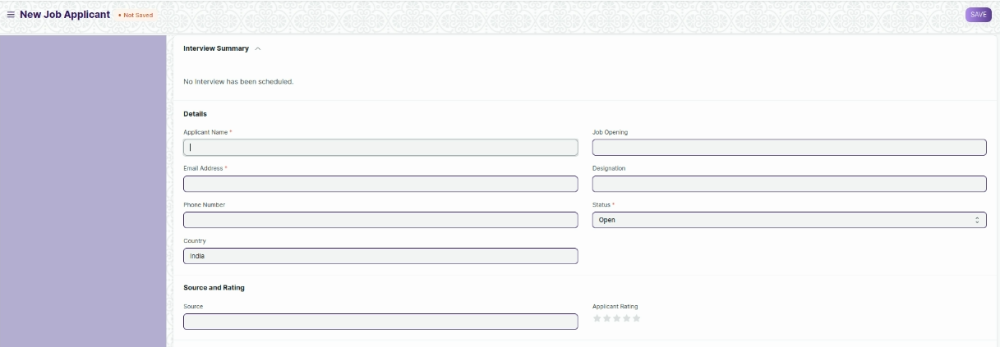

#### **Business Requirements:**

* Provision to add previous company history along with the documents should be there.
* There should be a “**table”** to maintain **“Educational Qualification”** with the fields like:

1. Name of School/University
2. Qualification
3. Level(Graduate/Post Graduate and so on)
4. Year of Passing
5. Percentage
6. Subjects(Major and Optional)

* There should be a provision to maintain whether an applicant has applied for any other position in the past.
* Aadhar card number field should be mandatory. The validations will be based on the Aadhar number.
* Resume Template should be uniform for all the employee.

### **Job Offer**

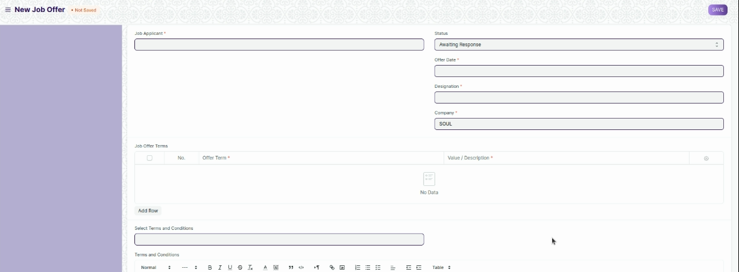

#### **Business Requirements:**

* Attachment fields to be added in job offer to upload documents.
* Depending on the type of employment, the documents that will be uploaded will be different

## **Employee Life-Cycle**

### **Employee On-boarding**

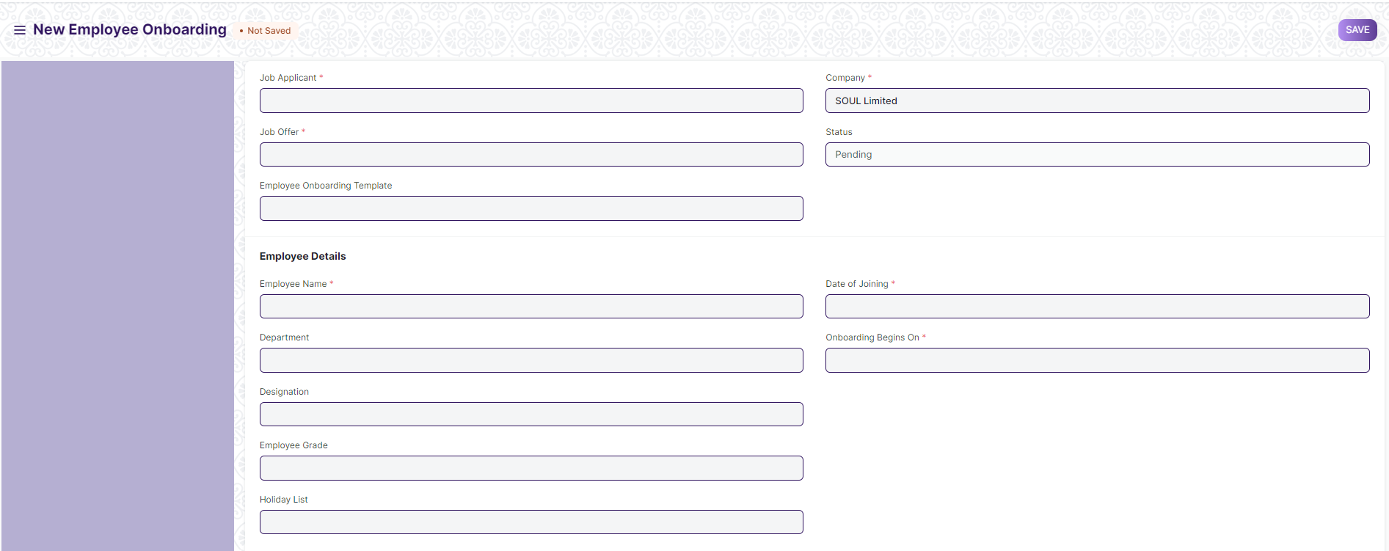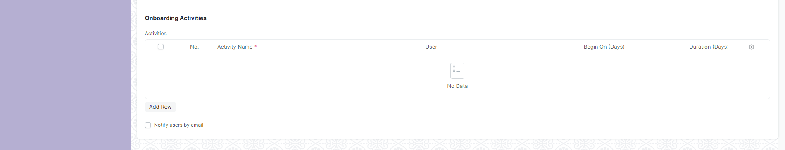

#### **Business Requirements:**

* There should be a standard template for Employee on boarding.
* In on boarding activity table , there should be another column "Status" (like : Completed ,Not Completed , Not Applicable)
* On boarding checklist will be same for everybody.

### **Employee Grievance**

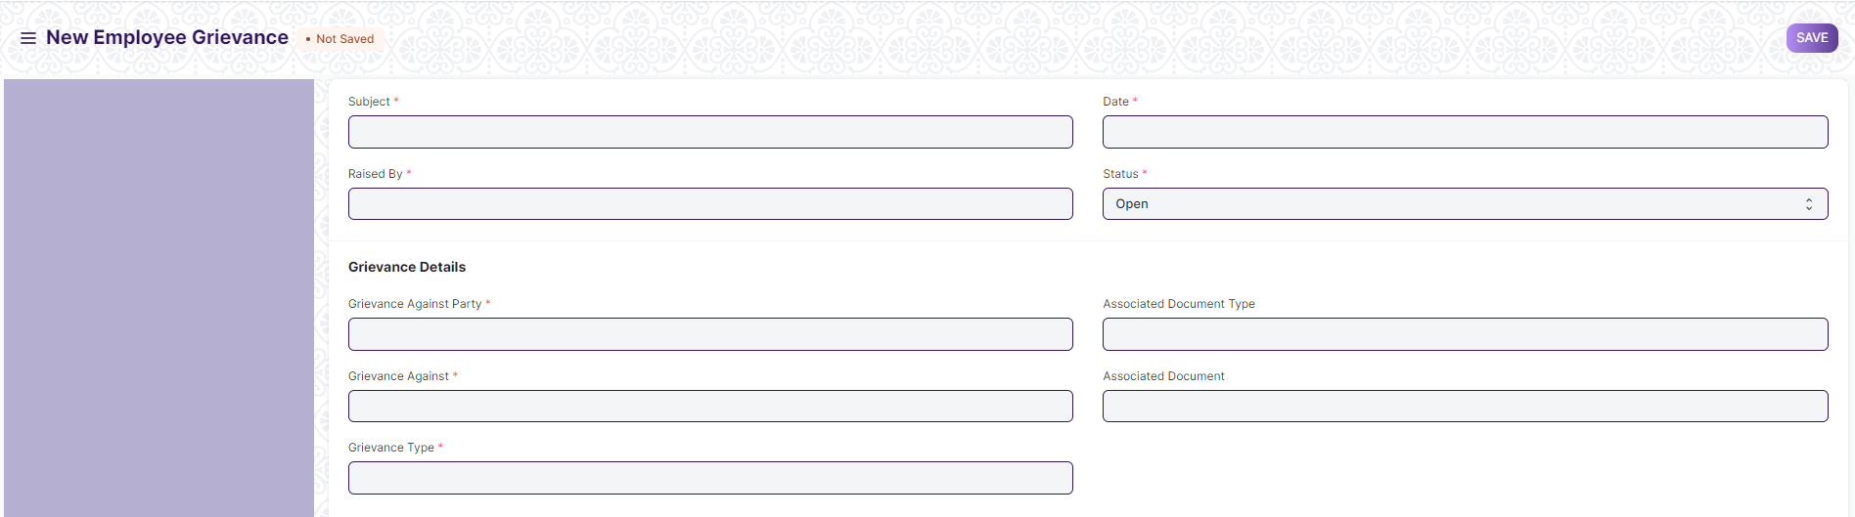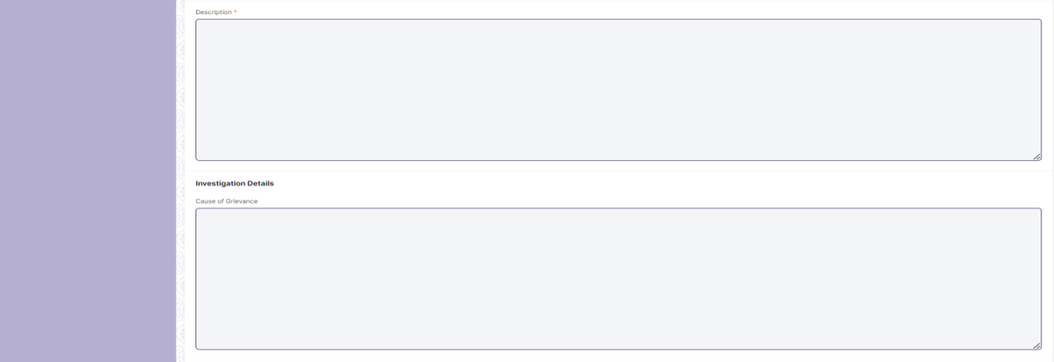

#### **Business Requirements:**

* There should be “**Attach”** field for uploading various required documents as a proof .
* There should be a **“Workflow” for Employee Grievance** and accordingly the authorities (Members of Grievance Committee) should be notified.

### **Employee Separation**

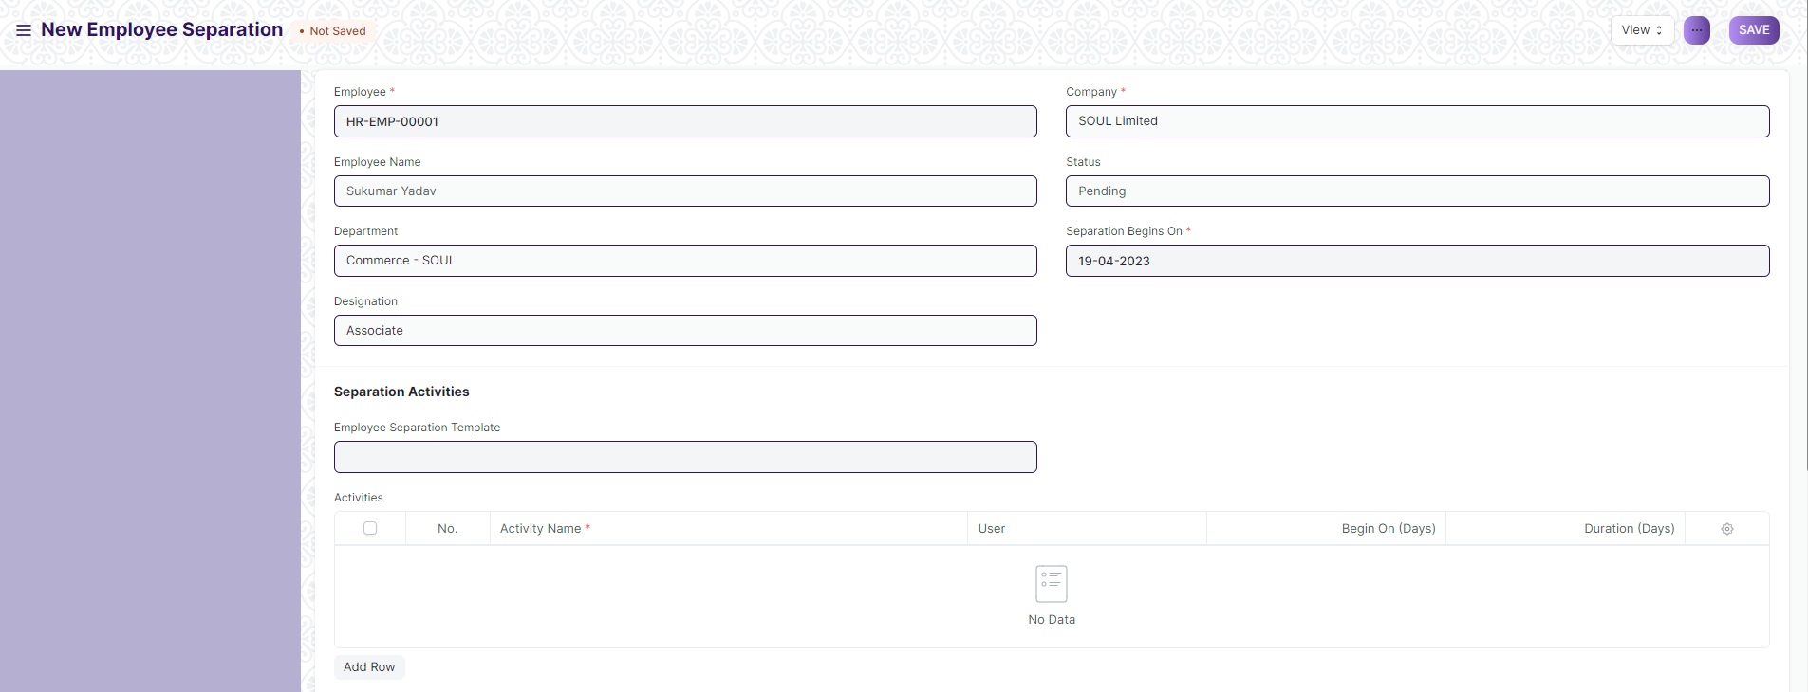

#### **Business Requirements:**

* Reason for Separation field should be there.
* There should be exit clearance in the form of checklist. It should contain the checklist status.
* Document upload options should be there in the employee separation screen.
* On submitting employee separation form, it will be forwarded to the immediate reporting authority.
* Reporting authority will verify the documents and the activities . After verification , it will be forwarded to the department head.
* Department head will decide the action (Approve/Reject) to do.
* If the department head approves , it will again forwarded to HR and HR will forward It the individual departments for clearance.

## **Leaves**

### **Leave Type**

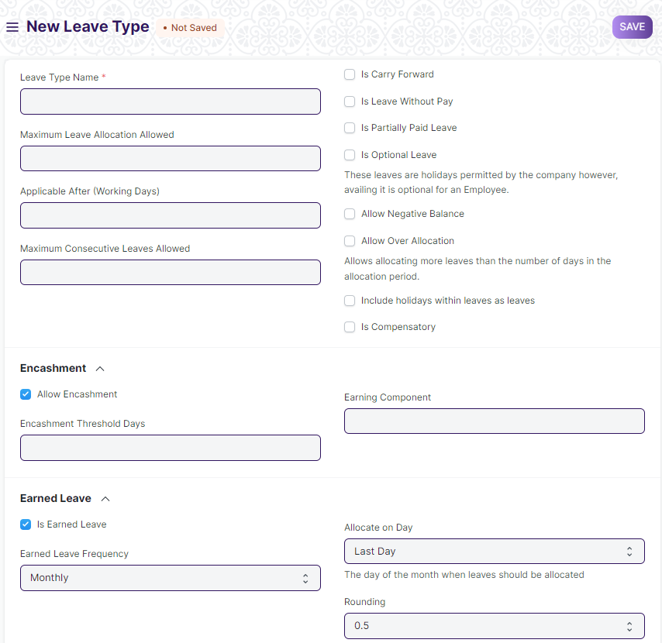

#### **Business Requirements:**

* Leave Type will be dependent on Category of employment.
* Employment Type Field should be there in the screen.

### **Leave Policy**

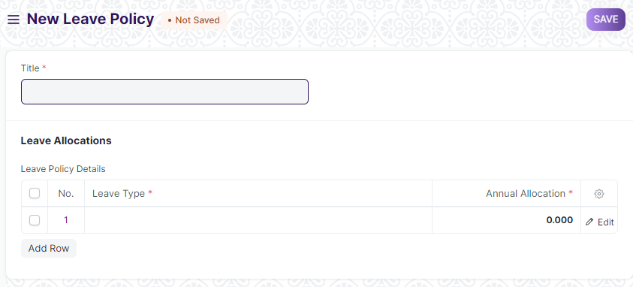

#### **Business Requirements:**

* Attachment field should be there in leave policy.

### **Leave Block List**

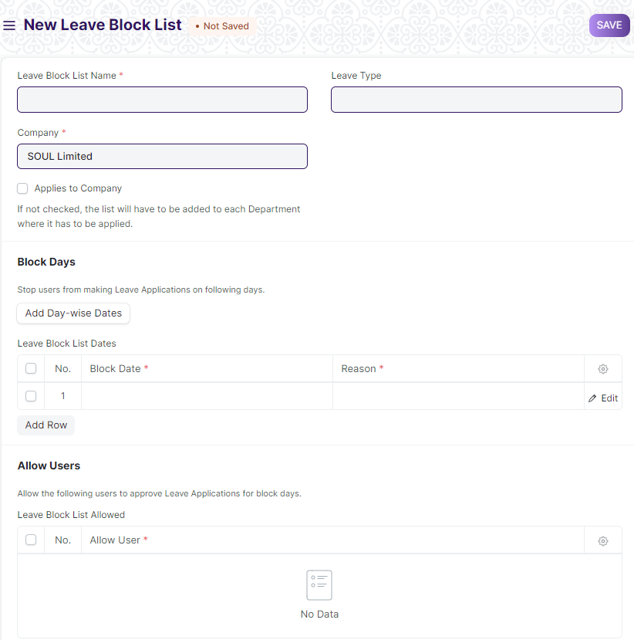

#### **Business Requirements:**

* Leave Block list should be based on employment type.
* Employment Type Field should be there in Leave Block list screen.

### **Leave Application**

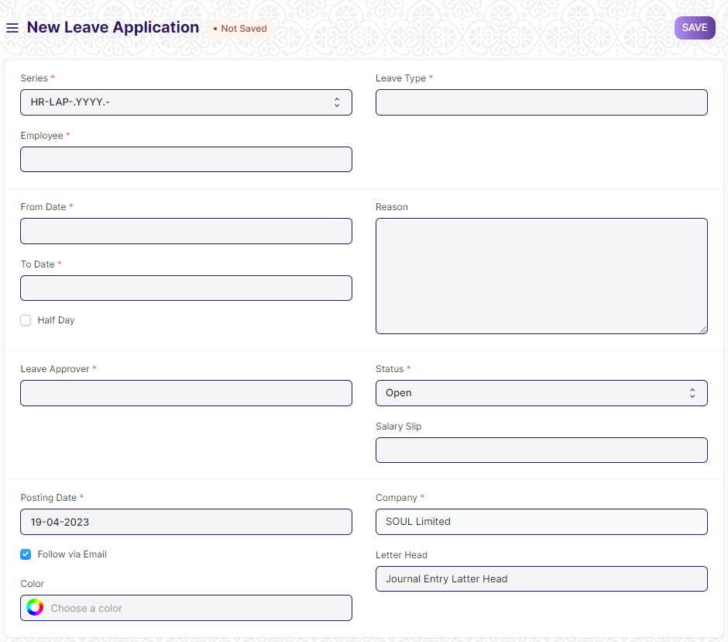

#### **Business Requirements:**

* Employment Type field should be added in the leave application.
* There should be two levels of authority , recommending and approving .

## **Attendance**

### **Attendance Request**

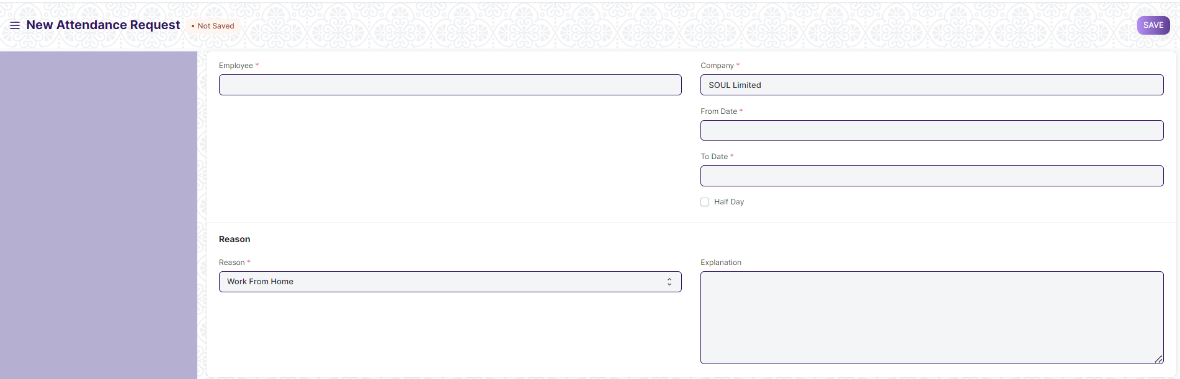

#### **Business Requirements:**

* There should be a provision for late entry and early exit attendance request.
* User should able to request for present date and future date attendance . Back date attendance should not be allowed.